**WEEK-3**

**Exercise 2: Implementing Dependency Injection**

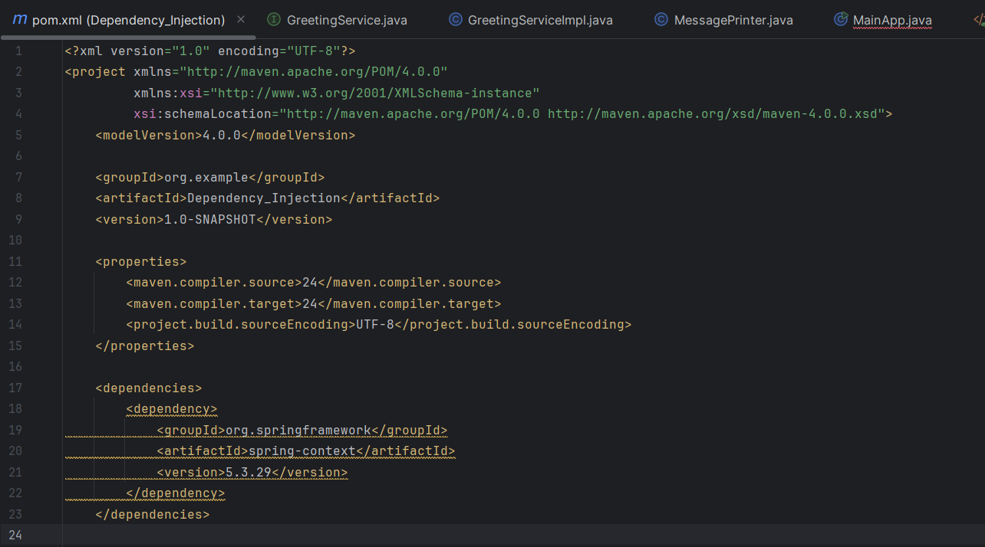

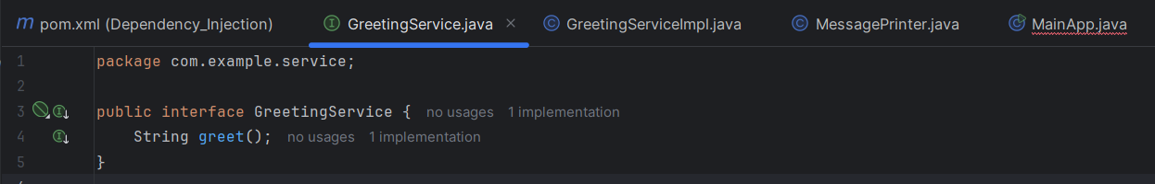

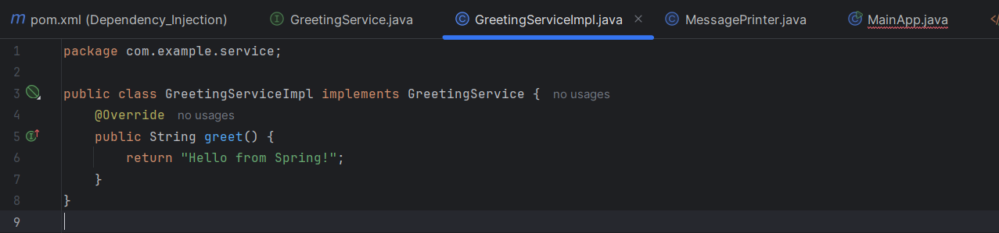

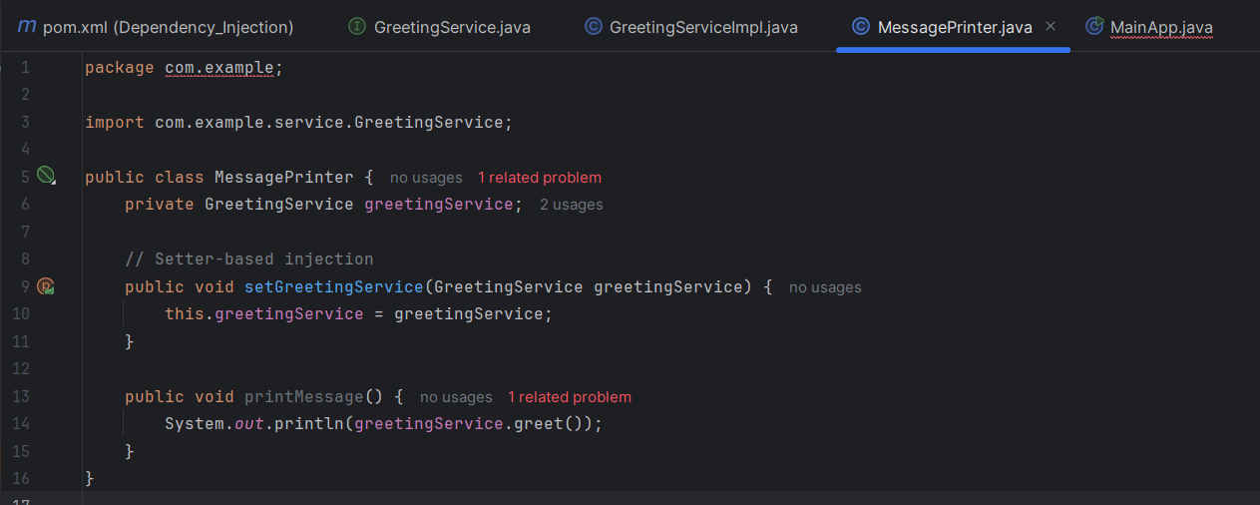

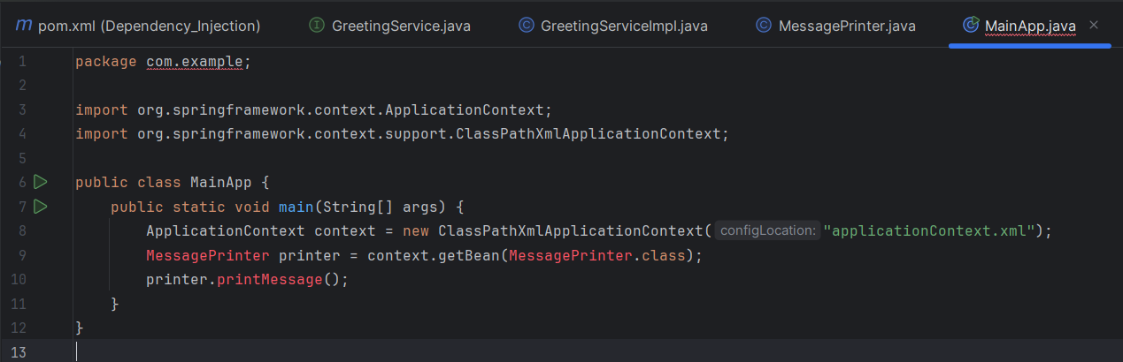

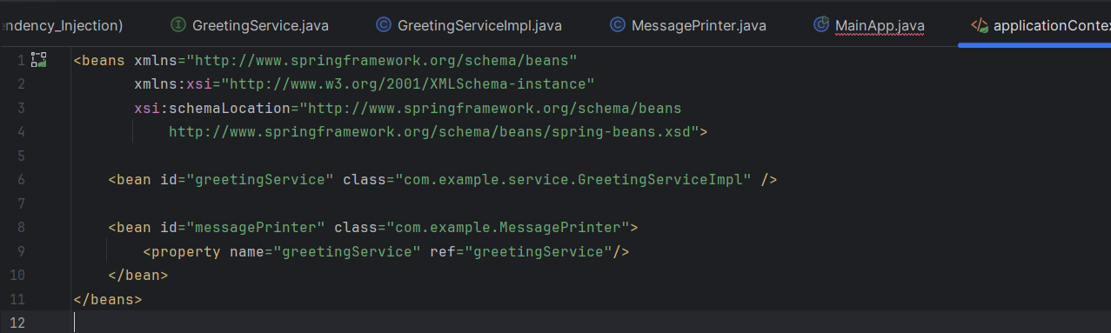

OUTPUT:

